**WORLDWIDE**

In **2016 and 2017**, the foundation awarded a **$75,000** grant to **AmeriCares** to offer aid to communities affected by natural disasters.

In **2016 and 2017**, the foundation awarded **$75,000** to **Save the Children** to provide aid to children in disaster zones.

**AFRICA AND MIDDLE EAST**

**BENIN**

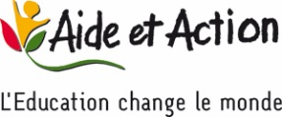

**Aide et Action**

* In **2015**, the foundation awarded a **$74,000** grant to [**Aide et Action**](http://www.aide-et-action.org/) to fund the digital component of a community mobilization project for six primary schools in Benin. Aide et Action aims to reduce inefficiencies and support technology integration in Benin schools, where more than one in five school-age girls and one in 10 boys do not attend school. The grant, which benefited **8,834** children, also included educational tools to increase student awareness of environmental issues, the need for proper hygiene, and health concerns including HIV/AIDS.

**DEMOCRATIC REPUBLIC OF THE CONGO**

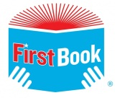

**First Book**

* The foundation provided funding for **425** high-quality new books, which were distributed in the Democratic Republic of the Congo through [**First Book**](https://www.firstbook.org/) in **2016**.

**EGYPT**

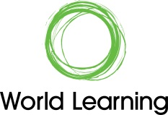

**World Learning**

* In **2015**, the foundation awarded a **$43,725** grant to [**World Learning**](https://www.worldlearning.org/) toprovide advanced Intel Core i5 laptops for **75** incoming students at the [**Maadi STEM School for Girls**](http://www.stemmaadi.edu.eg/) in Cairo, Egypt, founded by World Learning. The cutting-edge STEM curriculum relies upon laptops capable of running high-powered applications, and students will pass them on after completing the programs.

**ETHIOPIA**

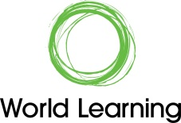

**World Learning**

* In **2013**, the foundation awarded a **$25,000** grant to [**World Learning**](https://www.worldlearning.org/) to translate and print **500** workbooks, and provide teacher training in financial literacy education for orphaned and vulnerable children in Ethiopia. More than **500** children benefited from the grant.

**GHANA**



**First Book**

* The foundation provided funding for **5,200** high-quality new books, which were distributed in Ghana through [**First Book**](https://www.firstbook.org/) in **2016**.



**Pencils of Promise**

* The foundation provided **$60,000** to sponsor the expansion of an e-reader program in Ghana with [**Pencils of Promise**](https://pencilsofpromise.org/) in **2015**. Four community schools in Ghana received **400** new e-readers loaded with **40,000** e-books. The e-readers were distributed to **900** students in grades 3-6 for use in their classrooms and at home. Nearly 25 percent of the Ghanaian population over the age of 15 is illiterate, and this was the first time most of the children, parents and teachers involved in the program had been introduced to technology.

**GUINEA**



**First Book**

* The foundation provided funding for **5,200** high-quality new books, which were distributed in Guinea through [**First Book**](https://www.firstbook.org/) in **2016**.

**IVORY COAST**



**First Book**

* The foundation provided funding for **425** high-quality new books, which were distributed in the Ivory Coast through [**First Book**](https://www.firstbook.org/) in **2016**.

**KENYA**

C:\Users\apn4\Documents\Logos\Grantee logos\Cooperative-bank-foundation-logo.png

**Co-operative Bank of Kenya Foundation**

* In **2015**, the foundation awarded a **$45,500** grant to the [**Co-operative Bank of Kenya Foundation**](https://www.co-opbank.co.ke/coop-bank-foundation)to help create and implement educational mentorship and career development programs. The program equips **444** underprivileged students in the seven regions and 47 counties of Kenya with essential psychosocial support to boost their academic performance and ensure they have the necessary skills to succeed in university and beyond.

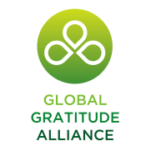

**Global Gratitude Alliance**

* In **2014**, the foundation provided a **$42,249** grant to the [**Global Gratitude Alliance**](http://www.gratitudealliance.org/) for **20** primary and secondary school scholarships and the construction of a new boarding house and computer lab for orphans living at the Maisha house in rural Kenya. The grant impacted **125** children.

**LEBANON**



**World Learning**

* In **2016**, through a **$41,250** grant to [**World Learning**](https://www.worldlearning.org/), the foundation provided 150 Lebanon schools with classroom material packs, which include a bookshelf, books, a reading carpet, radio/CD player, a flipchart, and stationery items. The grant will benefit over **19,500** students.

**LIBERIA**



**First Book**

* The foundation provided funding for **425** high-quality new books, which were distributed in Liberia through [**First Book**](https://www.firstbook.org/) in **2016**.

**MOROCCO**



**JA Worldwide**

* The foundation awarded **$14,920** to [**INJAZ Morocco**](http://injaz-morocco.org/) in **2017** to provide curriculum and training materials for programming spanning financial literacy, entrepreneurship and college and career readiness. The grant will benefit **650** high-school students in Casablanca.

**NIGERIA**



**First Book**

* The foundation provided funding for **425** high-quality new books, which were distributed in Nigeria through [**First Book**](https://www.firstbook.org/) in **2015**.



**First Book**

* In **2016**, the foundation provided funding for **5,200** high-quality new books, which were distributed in Nigeria through [**First Book**](https://www.firstbook.org/).

H:\Pictures\Logos\2017 Q2\world reader logo.png

**World Reader**

* In **2017**, the foundation donated **$75,590** to [**World Reader**](https://www.worldreader.org/)for the purchase of E-readers and to implement digital reading programs in three primary schools in Nigeria in partnership with the Christianna Foundation. The programs and technology will benefit **2,000** students.

**RWANDA**

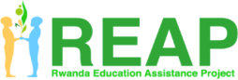

**Rwanda Education Assistance Program (REAP)**

* In **2016**, the MoneyGram Foundation awarded a **$45,000** grant to the [**Rwanda Education Assistance Program (REAP)**](http://www.reaprwanda.org/), which funded the construction of a library that had been destroyed by a storm. The grant also equipped the library with solar energy panels, books, iPads and computers. The library will serve over **3,400** students at the Duha Complex School as well as the greater community.

**SENEGAL**



**BuildOn**

* In **2017**, the foundation awarded **$30,000** to [**BuildOn**](https://www.buildon.org/)to build a primary school in the Thiès region, providing **3,000** students with a central place for learning.

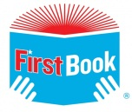 **First Book**

* The foundation provided funding for **5,200** high-quality new books, which were distributed in Senegal through [**First Book**](https://www.firstbook.org/) in **2015**.

**SOUTH AFRICA**

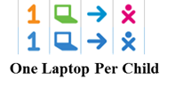

**One Laptop Per Child**

* In **2013**, the foundation launched the first [**One Laptop Per Child**](http://one.laptop.org/) project in South Africa by awarding a **$75,000** grant to supply **250** rugged, low-cost XO laptops to children in Orange Farm.

**ZAMBIA**

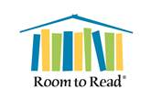

**Room to Read**

* In **2014**, the foundation awarded a **$51,209** grant to [**Room to Read**](http://www.roomtoread.org/), to support the development of innovative reading and writing curriculum in Zambia, benefiting **1,750** students. Room to Read is a U.S.-based global nonprofit that works to improve literacy and gender equality in education by collaborating with communities and local governments across Asia and Africa.

**ZIMBABWE**

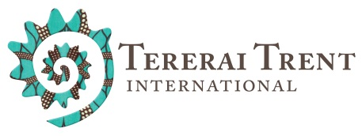

**Tererai Trent International**

* In **2017**, the foundation provided **$63,600** to [**Tererai Trent International**](http://tererai.org/)to establish well-equipped reading camps by constructing shelters, adding solar power to a library and providing tablets and books. The grant, which will benefit more than **4,000** students, was designed to instill a love of reading beyond the classroom.

## ASIA AND PACIFIC

**AUSTRALIA**

 **The National Theatre for Children**

* The [**National Theatre for Children**](http://nationaltheatre.com/) in Sydney, Australia, was given a **$49,500** grant in **2014** to fund a financial literacy program and curriculum for 10 middle schools. The program, “Mad About Money,” benefits **4,250 middle-school students** who will learn the value of budgeting, money management and investing for their future economic security.

**BANGLADESH**

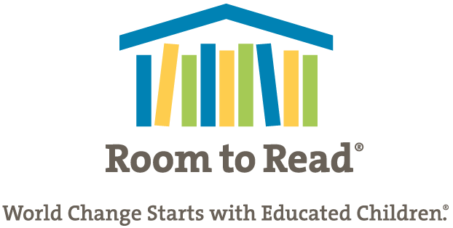

**Room to Read**

* The foundation awarded more than **$51,330** to [**Room to Read**](https://www.roomtoread.org/) in **2017** for program materials needed to implement a literacy program at two primary schools in Bangladesh, benefitting **1,500** students in need.

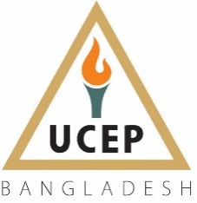 **Underprivileged Children’s Educational Programs**

* In **2015**, a grant was given to [**Underprivileged Children’s Educational Programs**](http://www.ucepbd.org/) (UCEP) to promote information and communication technology access at 27 UCEP Bangladesh community schools for underprivileged students. The **$53,600** grant enabled the purchase of learning equipment and materials such as laptops, software and other multimedia hardware, and provided equipment maintenance and training. The program impacted nearly **18,000 children** and enabled UCEP teachers to deliver math and science lessons in a more effective and meaningful way.

**CAMBODIA**

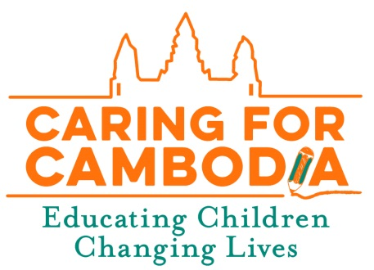 **Caring for Cambodia**

* In **2015**, the foundation funded the development of an ESL pilot program through [**Caring for Cambodia**](http://caringforcambodia.org/)(CFC), which has 21 campuses throughout the country. The newly developed course also teaches curricular goals in science and math among other subjects, and is significant when considering English language skills drastically increase Cambodians’ prospects of employment. The **$46,000** grant impacted **600 students and 20 teachers** in the funded pilot year.

**INDIA**

 **Agastya International Foundation**

* In **2017**, the foundation awarded **$60,100** to **Agastya International Foundation** to continue funding **three** mobile science labs that travel to Darbhanga, Mumbai and Aligarh. The labs will educate **21,600** economically disadvantaged children and **180** government school teachers through teacher trainings.
* The foundation awarded a third grant in **2016** to [**Agastya International Foundation**](http://www.agastya.org/) to continue funding the three mobile science labs, which continue to serve economically disadvantaged children and government school teachers in rural areas of India. The **$64,011** contribution also includes training 180 teachers, and ultimately will benefit **21,600 additional students**.
* In **2015**, the foundation continued to support [**Agastya International Foundation**](http://www.agastya.org/) by providing **$67,105** in additional funding for the three mobile science labs to travel throughout rural areas in India, including Navi Mumbai, Maharashtra, Darbhanga, Bihar and Aligarh. The mobile labs offered **21,600 children** the chance to learn, provided essential training to 180 teachers, and gave 66,000 rural residents access to STEM curriculum.
* In April **2014**, the foundation provided a **$59,916** grant to the [**Agastya International Foundation**](http://www.agastya.org/), funding the operation of three mobile science labs, which in total impacted more than **21,000 children**. Each lab traveled to 30 schools in rural India, teaching children through hands-on science models in physics, chemistry, biology and math.

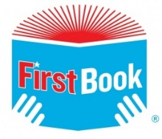 **First Book**

* The foundation provided funding for **5,625** high-quality new books, which were distributed across India through **First Book** in **2015**.

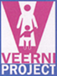 **Maharaja Hanwant Singh Ji Charitable Trust**

* In **2013**, the foundation awarded **$50,000** to Maharaja Hanwant Singh Ji Charitable Trust, supporting more than 30 percent of the [**Veerni Project**](http://www.veerni.com/about.aspx), which provides room, board and tuition to a private school for rural, impoverished girls in Jodhpur, India. The grant impacted **750 children**.

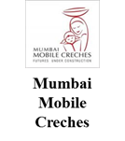 **Mumbai Mobile Creches**

* In **2013,** the foundation awarded an **$11,200** grant to [**Mumbai Mobile Creches**](http://mumbaimobilecreches.org/) to provide yearlong funding for six teacher salaries and educational materials to education centers where **4,500 children** of migrant workers were living temporarily on construction sites.

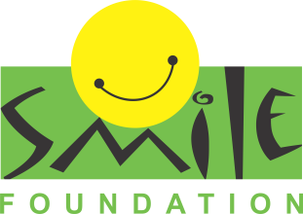  
  
**Smile Foundation**

* In **2017**, the foundation granted **$36,000** to the **Smile Foundation** to provide underprivileged children in Hyderabad with educational support including learning materials and school supplies. The grant will benefit **200 students**.

**INDONESIA**

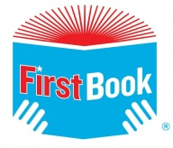 **First Book**

* The foundation provided funding for **425** high-quality new books, which were distributed across Indonesia through [**First Book**](https://www.firstbook.org/) **in 2015**.

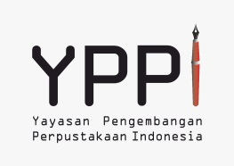 **Yayasan Pengembangan Perpustakaan Indonesia (YPPI)**

* The foundation again supported [**Yayasan Pengembangan Perpustakaan Indonesia**](http://pustakaindonesia.org/yppi/) (YPPI) in **2017**, by awarding **$63,100** for **1,000** books and to fund **one** mobile library that increased access to reading materials and promoted literacy among **2,700 students** in Tulungagung, East Java.
* In collaboration with the Bank of Indonesia, a MoneyGram International partner in business, the foundation awarded a grant to [**Yayasan Pengembangan Perpustakaan Indonesia**](http://pustakaindonesia.org/yppi/) (YPPI) in **2015**. The **$23,300** grant enabled YPPI to purchase **10,000 books** and host 50 drives in Jakarta to supply thousands of new books for struggling libraries in Indonesia, where there is a critical lack of access to reading materials. The drives also promote student and community engagement through storytelling and other educational activities.

**LAOS**

**Pencils of Promise**

* The foundation further supported [**Pencils of Promise**](https://pencilsofpromise.org/) in **2017** by awarding **$35,000** to build a school in the Kang Community in the Luang Prabang province, benefiting **1,380** **students**. Before the school was erected, students attended classes in a wooden structure with bamboo walls, dirt floors and no ventilation, resulting in a hot and muggy environment.
* In **2016**, the foundation awarded a **$35,000** grant to fund one of 14 schools [**Pencils of Promise**](https://pencilsofpromise.org/) will build in the Luang Prabang Region of Laos, benefiting **2,000 children**. Each school has four classrooms and a minimum lifespan of 20 years.

**MYANMAR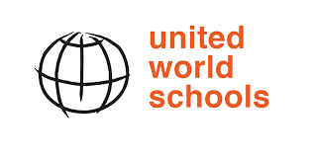 United World Schools**

* In **2017,** [**United World Schools**](http://www.unitedworldschools.org/) received **$60,000** for the construction of two hub schools and four satellite schools in Shan State, Myanmar, which will benefit **2,640 students**.

**NEPAL**

 **Chaudhary Group**

* In response to the devastating April 2015 earthquake that damaged or destroyed more than 20,000 school buildings, the [Chaudhary Group](http://www.chaudharygroup.com/) committed to building 100 semi-permanent schools. The foundation worked in partnership with the [Chaudhary Foundation](http://www.chaudharyfoundation.org/), and donated $77,000 to fund 10 of these schools in Sindhupalchowk, Lalitpur, Dolakha, Dhading, Kabhre, Gorkha, Ramechhap, Kathmandu and Bhaktapur. Overseen by Nepal’s ministry of education department, the renovation effort will benefit more than 5,000 children.

 **First Book**

* The foundation provided funding for **425 high-quality new books** through [**First Book**](https://www.firstbook.org/), which were distributed across the country in **2015**.

**PAKISTAN**

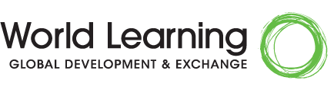 **World Learning**

* [**World Learning**](https://www.worldlearning.org/) received **$50,000** from the foundation in 2017 for the purchase of **15,000** culturally relevant and educational books to give to **100** schools in the Azad Jammu and Kashmir region, benefitting **5,000** students.

 **Developments in Literacy**

* In **2016**, the foundation provided **$38,012** to [**Developments in Literacy**](http://www.dil.org/) to fully cover operational and administrative costs at Nai Abadi school in Rawalpindi – a school with 70 percent female enrollment. The grant benefited **300 students**.
* In **2015**, through a **$65,000** grant to [**Developments in Literacy**](http://www.dil.org/), the foundation impacted 704 students by continuing to fund operations for three schools in Rawalpindi, and by providing 32 scholarships for children in grades 10 and above to continue their secondary education. The schools proudly report less than a one percent dropout rate, low compared to the country’s overall 45 percent dropout rate.
* In **2014**, the foundation renewed funding for two schools in Rawalpindi, and provided 32 scholarships through an additional **$49,802** grant to [**Developments in Literacy**](http://www.dil.org/)**,** benefiting more than **700 students**. The cost of each female-majority school is about $20,000 yearly, and impact spreads beyond the several hundred girls enrolled in each school to their families and communities.
* In **2013**, the foundation awarded a **$63,800** grant to [**Developments in Literacy**](http://www.dil.org/) to fund three schools with 70 percent female enrollment in Rawalpindi, Pakistan. The school ultimately will benefit **750 students** in rural and impoverished regions where nearly 75 percent of girls are illiterate.



**First Book**

* The foundation provided funding for **425 high-quality new books**, which were distributed across **Pakistan** through **First Book** in **2015**.

**PHILIPPINES**

  
**Black Pencil Project**

* The foundation awarded **$25,000** in **2017** to the **Black Pencil Project** to provide **12** barrio schools with a “School-In-A-Box” program kit that includes school equipment and supplies for teachers and students. The boxes ultimately benefit **5,000** students.
* In **2016**, the MoneyGram Foundation awarded **$21,000** to the **Black Pencil Project** to provide **six** barrio schools with a “School-In-A-Box” program kit that includes school equipment and supplies for teachers and students. Each box is delivered on foot by volunteers and contains a Kindergarten to Grade 6 complete study pack, teacher’s tool kit and relevant learning resource materials. The boxes benefitted **2,500** students.



**First Book**

* Through **First Book**, the foundation provided funding for **425** high-quality new books, which were distributed across the **Philippines in 2015**.

 **Habitat for Humanity Philippines**

* In **2015**, through a second grant to [**Habitat for Humanity Philippines**](http://www.habitat.org.ph/), the foundation provided **$60,000** for the construction of two typhoon- and earthquake-resistant single-room school structures in the Province of Capiz, Philippines, which was damaged by Typhoon Haiyan. The structures are small, 10-year shelters designed to withstand natural disasters, benefitting more than **500 students** and also community members.
* The foundation awarded a **$50,000** grant to [**Habitat for Humanity Philippines**](http://www.habitat.org.ph/) in **2014** to rebuild three classrooms destroyed by Typhoon Yolanda and an earthquake. The classrooms not only benefit **5,000 students** by providing shelter in future disasters, they also support the department of education’s efforts to rebuild in calamity-stricken areas.

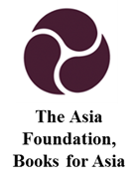 **The Asia Foundation**

* In **2013**, the foundation awarded a **$30,616** grant to [**The Asia Foundation**](http://asiafoundation.org/) for the provision of 25,000 brand-new books to about 500 schools throughout the Philippines, ultimately impacting **500,000 children**.

**THAILAND**

 **The Asia Foundation**

* The MoneyGram foundation awarded a **$60,000** grant in **2016** to [The Asia Foundation](http://asiafoundation.org/)to develop and implement an e-reader app within the S’gaw Karen community in northern Thailand through their *Let’s Read Asia* program. The program will dramatically increase the number of children’s books accessible in the S’gaw Karen language as well as establish sustainable mechanisms and develop community capacity to continue to add and access children’s content. The project will initially involve 10 communities and will have a direct impact on an estimated **1,000 underserved children**.

**VIETNAM**

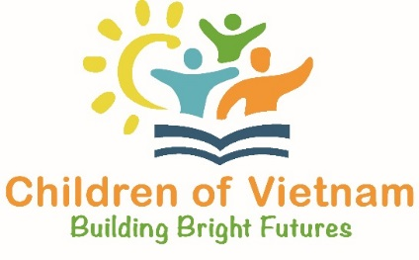 **Children of Vietnam**

* In **2017**, the foundation funded the construction of a kindergarten in the T’Ghey village in the Tây Giang District through [**Children of Vietnam**](http://www.childrenofvietnam.org/). The 20-year school, which cost **$18,130**, will benefit **400** students in an area where less than 50 percent of children enroll in kindergarten.
* In **2016**, [**Children of Vietnam**](http://www.childrenofvietnam.org/) received a **$20,607** grant from the foundation for the construction of a weather-resistant school in A Pat village in the Tây Giang District. The school, which benefits **600 students**, now boasts a water system, indoor plumbing, an awning for shade, a ceiling fan, and an electrical system and lighting.
* In **2015**, the foundation provided **$16,980** for 100 student scholarships and the construction of a two-classroom primary school in same rural district of Vietnam through [**Children of Vietnam**](http://www.childrenofvietnam.org/). The kindergarten now serves the 420-person C'Tu community in Dang Commune called Batul, where 80 percent of the households are considered very poor. Designed to stand for 20 years, the primary school also teaches proper hygiene and serves as a shelter for the community. In its first year, the school benefited 15 kindergarten students and over 40 additional students in grades 1-3, benefitting **1,320 students**.
* In **2014**, through [**Children of Vietnam**](http://www.childrenofvietnam.org/), the foundation funded the construction of a kindergarten in the rural Tay Giang district, where less than 47 percent of children enroll in kindergarten. The 20-year school, which cost **$16,000** to build, serves 45 students, ultimately benefitting **900 children**.

# **EUROPE**

**GERMANY**

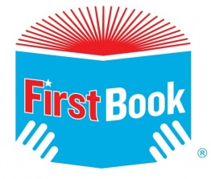 **First Book**

* The foundation provided funding for **425 high-quality new books**, which were distributed in Germany through [**First Book**](https://www.firstbook.org/) in **2015**.

**ITALY**

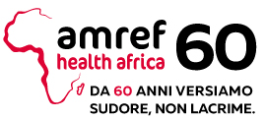  
  
**Amref Health Italy**  
  
In 2017, the foundation granted **$20,000** to [**Amref Health Italy**](http://amref.org/tags/?tag=Italy) to foster academic growth and collaboration between students in Italy and in Kenya, ultimately impacting **6,300**.

**KOSOVO/MACEDONIA**



**Kosovo Education Center**

* A **$65,580** grant to the [**Kosovo Education Center**](http://amref.org/tags/?tag=Italy) was provided in 2017 by the foundation to equip first-grade classrooms in Kosovo and Macedonia with sets of **15** customized, culturally relevant and age-appropriate books. The grant also funded the translation and printing of books, the training and monitoring of teachers on implementing companion curriculum, and project management. The grant will benefit **48,000** students.

**POLAND**

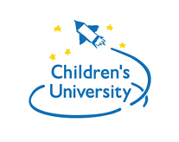 **Children University Foundation**

* Employees at MoneyGram’s Warsaw office voted from among five non-profit organizations in Poland for the[**Children University Foundation**](http://fundacja.uniwersytetdzieci.pl/en/) to receive a grant, and in **2015**, the foundation provided **$54,000** to develop interactive educational events and conferences for science teachers. The programs enable teachers to build effective lessons to excite students, and have impacted nearly **600 teachers** and more than **40,000 students.**

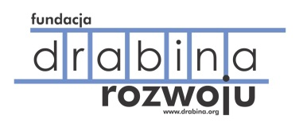 **Development Ladder Foundation**

* In **2014**, the foundation awarded a **$52,189** grant to the [**Development Ladder Foundation**](http://www.drabina.org/63_About.html) in Warsaw to supply orphanages with teacher training programs, and computers and customized education software. At the end of the program, the orphans applied their entrepreneurial skills to organize a community concert. The grant benefited **150 children**.

**ROMANIA**

Save the children logo **Save the Children**

* In **2014**, [**Save the Children**](http://www.savethechildren.org/site/c.8rKLIXMGIpI4E/b.6115947/k.B143/Official_USA_Site.htm) received a **$59,872** grant to support the reintegration of **60 children** from disadvantaged communities into public schools in Bucharest, Romania. Through the Second Chance Program, the grant will enable children who have dropped out of school -- or who never previously attended – to fully integrate into public schools with the goal of finishing their education.

**UKRAINE**

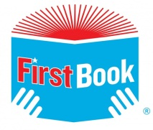 **First Book**

* The foundation provided funding for **425 high-quality new books**, which were distributed to a school in Ukraine through [**First Book**](https://www.firstbook.org/) in **2015**.

## LATIN AMERICA, SOUTH AMERICA AND THE CARIBBEAN

**BRAZIL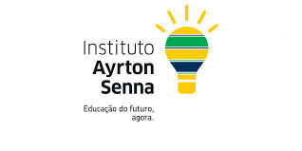 Ayrton Senna Institute**

* In **2017**, the foundation granted **$75,000** to the [**Ayrton Senna Institute**](http://www.sennaworld.com/asf.html) to fund the school learning policy that works to reduce illiteracy and the age-grade distortion in elementary schools in Manaus, Brazil’s third-largest municipality. The grant will benefit **6,500** students.

**CARIBBEAN**

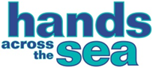 **Hands Across the Sea**

* **In 2014**, the foundation provided **$29,200** to fund library renovations in Antigua and Barbuda, the Commonwealth of Dominica, St. Lucia, St. Vincent, and the Grenadines and Grenada with [**Hands Across the Sea**](http://handsacrossthesea.net/). The grant benefits **2,652 children** at the selected schools, which are in either a rural village or in an underserved community on one of the seven islands.

**COLUMBIA**

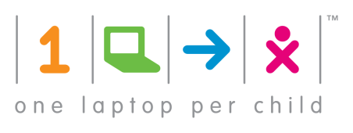 **One Laptop Per Child**

* The foundation awarded **$75,000** to[**One Laptop Per Child**](http://one.laptop.org/) (OLPC) **in 2015** for a technology project in Bogotá, Colombia, where only 62 percent of students who enter primary schools finish sixth grade. The project supplied **150 laptops** and computer programming and robotics technology kits to children in five underprivileged public schools, benefiting **1,250 students**. Each project was taught by a university student as a part of their professional practicum, and the end results were presented at the Creatic Science Fair at Universidad Minuto de Dios.

**COSTA RICA**

 **One Laptop Per Child**

In **2017**, the foundation awarded **$88,300** to **One Laptop Per Child** to fully fund the implementation of an educational technology program in up to three schools in Santa Bárbara de Heredia. The grant covered the purchase of **300** laptops benefitting **300** students in the community.

**ECUADOR**

Techo logo **TECHO**

* The foundation supplied **$17,280** toward academic programs for underprivileged children through [**TECHO**](http://www.techo.org/) in **2014**, impacting **600 children**.

**EL SALVADOR AND HAITI**

SAHF logo **Salvadoran American Humanitarian Foundation**

* The [**Salvadoran American Humanitarian Foundation**](http://www.sahf.org/) (SAHF) distributes educational and medical supplies, and also offers [**Proyecto PaÍs**](http://www.fusal.org/programas/proyecto-pais), a program to help more than **8,000 children** stay in school, on track, and away from violence. In 2014, the foundation awarded a **$44,990** grant to provide English language courses to Proyecto PaÍs participants through in-country sister organization FUSAL, **benefiting 700 children.**

Techo logo **TECHO**

* The foundation provided a **$69,992** grant in **2013** to [**TECHO**](http://www.techo.org/), to support academic programs for children living in poor conditions in rural areas throughout El Salvador and Haiti.

**GUATEMALA**

**child aid logo  
  
Child Aid**

* The foundation supported a [**Child Aid**](http://child-aid.org/) program in **2013**, which translated books for over **30 libraries and 43 schools** through [**Reading for Life**](http://www.readingforlife.us/)**,** which helps more than **9,500 children** in over 50 Guatemalan villages by providing literacy education and materials, training for teachers, and new library buildings. Our grant totaled **$10,000 and impacted 4,250 students.**

**HAITI**

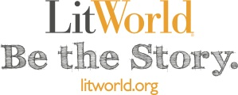 **LitWorld**

* In **2015**, the foundation funded the expansion of [**LitWorld**](http://www.litworld.org/)**’s** existing literary and library program in Haiti, where LitWorld also provides year-round LitClubs and LitCamps. These programs are a vital literacy lifeline in Port-au-Prince and the surrounding areas, where less than 30 percent of children go to secondary school, and where areas affected by the 2010 earthquake are still in desperate need of books written in Haitian, Creole and French. The **$45,500** grant impacted **450 students** by funding additional program space, and library books and technology.

 **First Book, Haiti**

* The foundation provided funding for **425** **high-quality new books**, which were distributed to students in Haiti through [**First Book**](https://www.firstbook.org/) in **2015**.

**JAMAICA**

 **First Book, Jamaica**

* In **2015**, the foundation donated books that were distributed across Jamaica through [**First Book**](https://www.firstbook.org/), and funded an additional donation through First Book in 2016, impacting **5,200 children**.

**MEXICO**

 **Niños en Alegría**

* The foundation continued to support [**Niños en Alegría**](http://ninosenalegria.org.mx/en/) in **2017**, providing **$50,000** to build a new primary school in Guerrero to benefit **136** disadvantaged children.
* In **2015**, the foundation renewed its support of [**Niños en Alegría**](http://ninosenalegria.org.mx/en/) to rebuild the Cuitláhuac School, which was damaged by local flooding. The United Way co-sponsored building the school, which serves more than **150** children in the community of El Conchero in the Municipality of Coyuca de Benítez. The building also acts as a shelter for the community during natural disasters.
* In **2013**, the foundation provided **$25,000** to [**Niños en Alegría**](http://ninosenalegria.org.mx/en/) for technology and business entrepreneurship instruction for more than 160 teachers working in seven elementary schools in Guerrero, Mexico, impacting **2,500 students**.

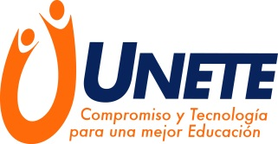  
**UNETE**

The MoneyGram Foundation awarded a grant of **$84,000** to [**UNETE**](http://www.unete.org/quienes-somos.html) in **2016**, which equipped eight schools in Jalisco and Mexico State, Mexico with technological infrastructure also added value to existing programs. Over **3,400 students and 118 teachers** will benefit from this grant.

**NICARAGUA**

**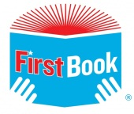  
  
First book, Nicaragua**

* The foundation provided funding for **5,200 high-quality new books**, which were distributed in Nicaragua through[**First Book**](https://www.firstbook.org/) in **2015**.

 **One Laptop Per Child**

* The foundation fully funded the implementation of educational program MathemaTIC in two schools in Chinandega, Nicaragua, in **2016** with [**One Laptop Per Child**](http://one.laptop.org/). The **$85,551** donation included **300 laptops and benefited 1,000 children.**

## UNITED STATES AND CANADA

**ARKANSAS**

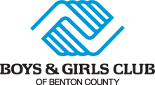 **Boys and Girls Club of Benton County**

* In **2014**, the foundation contributed **$10,000** toward a summer reading program for more than **100 children** and afterschool tutoring for at-risk children in Bentonville, Bella Vista and Rogers, Arkansas, through the [**Boys and Girls Club of Benton County**](http://www.bgcbentoncounty.org/).

**CALIFORNIA, NEW YORK, MIAMI, TEXAS**

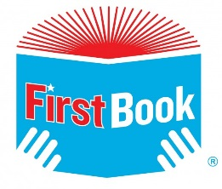 **First Book, USA**

* The foundation granted **$25,500** to [**First Book**](https://www.firstbook.org/) in **2017** to distribute **5,000** books in three large cities (Chicago, Dallas and LA), reaching **500** students in need of reading materials. Donation events tied to Día de los Libros (Children’s Book Day) included special guests and activities designed to further inspire a love of reading among attendees.
* The foundation also granted **$60,000** to **First Book** for the purchase of **25,000** books benefiting **16,000** students worldwide in **2017**. The giveaway was hosted through social media.
* In **2016**, the foundation awarded **$20,0000** to [**First Book**](https://www.firstbook.org/) to supply **15,000 books** to schools in Dallas, Los Angeles, New York and Miami for the 20-year anniversary of Dìa de los Libros (Children’s Book Day), and to bolster efforts to increase literacy.
* The foundation provided funding for **425 high-quality new books**, which were distributed in various cities across the U.S. through [**First Book**](https://www.firstbook.org/) in **2015**.

**FLORIDA**

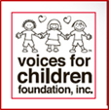 **Voices for Children Foundation, Inc.**

* In **2013**, the foundation provided **$40,000** for more than **650 school uniforms** for abused or neglected children ages 6-12. The uniforms were handed out at the [**Voices for Children Foundation, Inc.**](http://beavoice.org/)Back-to-School event in Miami.

**ILLINOIS**  
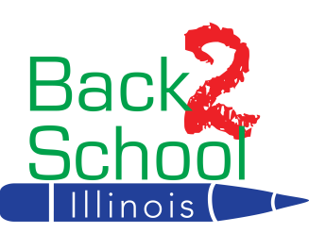  
**Back 2 School, Illinois**

* In **2017**, [**Back 2 School Illinois**](http://b2si.org/) received **$62,500** for “Back 2 School” kits filled with about **30** necessary core supplies benefiting **4,000** K-12 students.

**MINNESOTA**

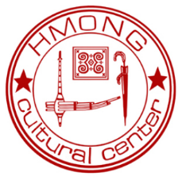 **Hmong Cultural Center**

* In **2015**, the MoneyGram Children’s Corner was developed in the Hmong Resource Center Library at [**Hmong Cultural Cente**r](http://www.hmongcc.org/) in St. Paul, Minnesota, with **$10,000** from the foundation. The children’s corner includes more than 450 books, which will benefit at least **250 children**, and also families: the library allows adult learners in ESL and citizenship classes to check out books to read to their children at home.

**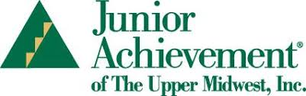  
Junior Achievement of the Upper Midwest**

* [**Junior Achievement of the Upper Midwest**](https://www.jaum.org/)received **$25,000** from the foundation in **2017** to provide programming and training materials on topics spanning financial literacy, entrepreneurship, and college and career readiness for at-risk students in the Twin Cities. The grant benefitted **625** students.

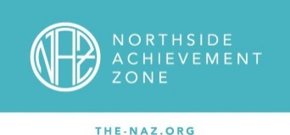 **Northside Achievement Zone**

* [**Northside Achievement Zone**](http://northsideachievement.org/) received **$60,000** from the foundation in **2017** to support an expanded learning program that will improve the academic growth of **40** students through employee engagement.

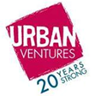 **Urban Ventures**

* In **2013**, the foundation provided **$15,000** to [**Urban Ventures**](http://urbanventures.org/) for refurbishing and supplying a classroom with technology needed for an eighth-grade Learning Lab. The lab provides **180 children** with year-round, afterschool curriculum enrichment, tutoring and homework help.

**NEW YORK**

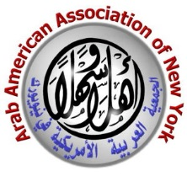 **Arab American Association of New York**

* In **2013**, the foundation contributed **$20,000** to the [**Arab American Association of New York**](http://www.arabamericanny.org/), for the Kitaab Club, an ESL literacy program. The grant enabled a part-time staff member to move to a full-time position, benefiting **150 students**.

**TEXAS**

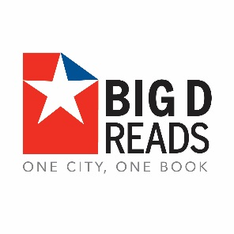 **Big D Reads**

* Dallas publication *D Magazine* established [**Big D Reads**](http://bigdreads.org/), a month-long reading program implemented in Dallas County and in the Dallas Independent School District (DISD). For the **April 2015** initiative, the foundation contributed **$5,000 for 12,000 books**. Through the program, more than **11,000 ninth-grade students** at 31 DISD schools received a copy of *True Grit,* the featured book, and another 500 books were given to students at Uplift Education charter schools. An additional 8,000 books were given to the Dallas community. MoneyGram International also sponsored kickoff event “Paint the Town Well Read,” which included a downtown light show promoting the program.

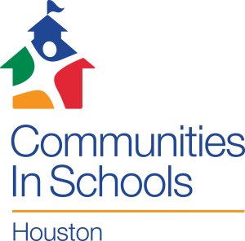 **Communities in Schools**

* The foundation awarded **$65,000** to [**Communities in Schools**](http://cishouston.org/) in **2017** to provide on-campus aid—including school supplies and uniforms—to **70** schools in the greater Houston area following the devastation from Hurricane Harvey, benefitting **700** students.

Dallas Theater Center **Dallas Theater Center**

* In **2014**, the foundation provided **$25,000** for [**Project Discovery**](https://www.dallastheatercenter.org/subpage.php?sid=68), a yearlong afterschool program for a diverse group of **360** teens from underrepresented high schools across North Texas. The grant provided theater arts education and access to professional theater productions at Dallas Theater Center**,** to facilitate creativity and critical thinking, and expose children to theater arts – in many cases, for the first time.

 **Dallas Urban Debate Alliance**

* The foundation provided the [**Dallas Urban Debate Alliance**](http://dallasurbandebate.org/) with a **$60,000** grant for the research and creation of core files for the **2014-2015** debate season to be used by students in the Dallas, Boston and Minnesota Urban Debate Alliances to prepare for competition. The alliance serves at-risk students in urban high schools throughout the country and also had materials translated into Spanish and Somali. Roughly **2,500 children** benefited from the grant, which helped increased test scores used for college admissions.

 **Junior Achievement of Dallas**

* In **2017**, the foundation again awarded **$25,000** to [**Junior Achievement of Dallas**](http://jadallas.org/)to support programs aimed at increasing financial literacy skills, economic awareness, and career readiness among more than **750** disadvantaged K-12 students in the Dallas Independent School District.
* The foundation awarded a **$25,000** grant to [**Junior Achievement of Dallas**](http://jadallas.org/) in **2016** to support programs aimed at increasing financial literacy skills, economic awareness, and career readiness among disadvantaged K-12 students in Dallas, Garland, Irving and Richardson during the fall of 2016. The grant benefited **757 students.**

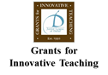 **Junior League of Dallas**

* In **2017**, the foundation awarded **$10,000** to the [**Junior League of Dallas**](https://www.jld.net/)complete the initial funding promised in 2013 to support the Grants for Innovative Teaching, or GFIT, program. The funds again benefitted K-12 Dallas Independent School District teachers in South Dallas schools, who are developing and implementing STEM and literacy projects.
* In **2013**, the foundation agreed to provide **$80,000** over four years to the [**Junior League of Dallas**](https://www.jld.net/) to support the Grants for Innovative Teaching, or GFIT, program. The unique program awards small grants to K-12 Dallas Independent School District teachers at South Dallas schools to support STEM and literacy projects. The teachers usually offer these projects after school and in addition to the required school curriculum.

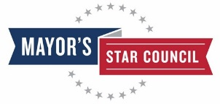 **Mayor’s Star Council**

* The foundation distributed a **$20,850** grant in **2015** to the [**Mayor's Star Council**](http://www.mayorstarcouncil.org/) to support community leadership projects in five under-resourced high schools in South Dallas and Oak Cliff in Dallas, benefiting **60 students**. The projects encourage student collaboration while establishing a culture of learning. The Mayor’s Star Council programs encourage young people to be leaders of change in their community, in school and with friends and family.

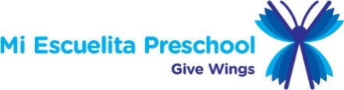 **Mi Escuelita**

* In **2016**, the MoneyGram Foundation funded the expansion of the [**Mi Escuelita**](http://miescuelita.org/) preschool program in Dallas, Texas, to help relieve extreme overcrowding in classrooms. The **$35,000** grant, which will benefit over **100 children**, also funded teacher trainings and classroom supplies.
* In **2013**, the foundation granted **$35,000** to [**Mi Escuelita**](http://miescuelita.org/)**,** a Dallas-based nonprofit that provides early childhood education to low-income, at-risk children in the Dallas area. The grant funded teacher salaries for three new classrooms in KIPP public charter schools to support newly implemented afterschool programs for 60 students, impacting **180 children**.

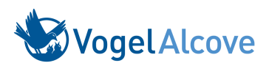 **Vogel Alcove**

* The foundation granted **$16,305** to Dallas-based **Vogel Alcove** in **2017** to provide supplemental educational programming for K-5 students during school holidays and summer breaks, benefiting **60** students up to age 12.

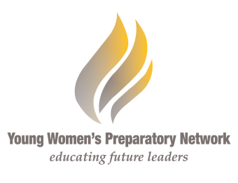

**Young Women’s Preparatory Network**

* In **2017**, the foundation awarded **$30,000** to **Young Women’s Preparatory Network** in Dallas to provide a full school year of STEM programming that will reach **1,920** female students in North Texas.